EXPERIMENT 10

Aim
Study of Wireshark and understand its functionality

Prerequisite
Nil

Outcome
To impart knowledge of Computer Networking Technology

Theory
Wireshark is a popular and powerful open-source network protocol analyser that allows users to capture, inspect, and analyse data traffic on a computer network. It is widely used by network administrators, security professionals, and developers to troubleshoot network issues, monitor network performance, and identify potential security vulnerabilities.
Wireshark boasts support for a wide array of network protocols, including common ones like TCP, IP, UDP, HTTP, and HTTPS, as well as less common or proprietary protocols. The tool can decode and display information about each packet, allowing users to understand the contents of network traffic and identify potential issues.
Here are some key aspects of Wireshark:
- Packet Capture
- Protocol Support
- Live Capture and Offline Analysis
- Display Filters
- Packet Inspection
- Statistics and Graphs
- Colour Coding
- Extensibility
- Cross-Platform
- Community and Support
- Security Analysis
- Educational Tool

Procedure
- Install the Wireshark and integrate it with network simulator
- Analyse the traffic using Wireshark
Output
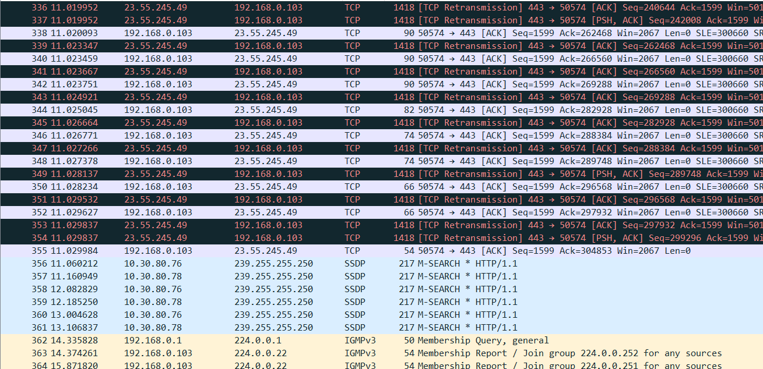
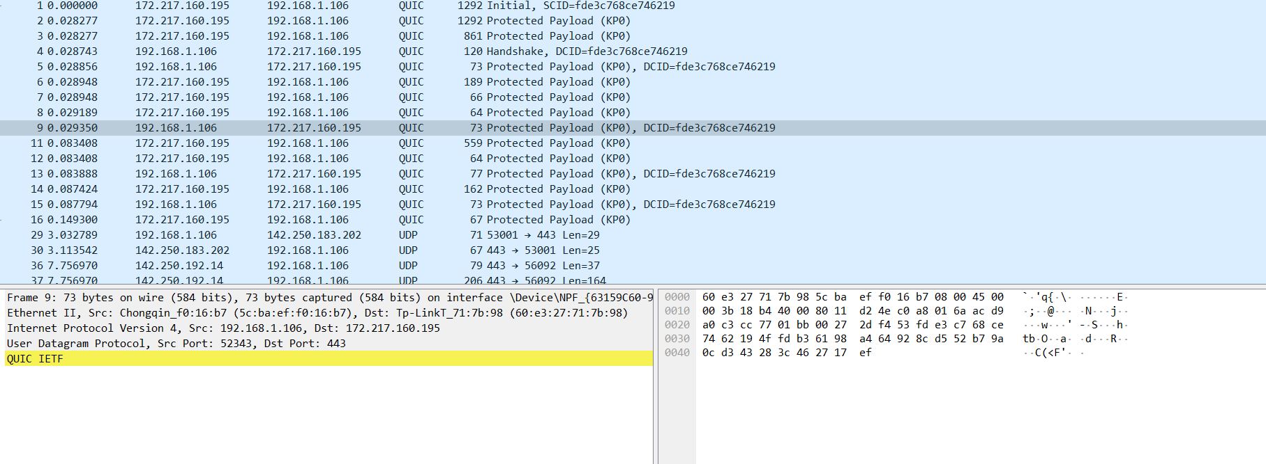
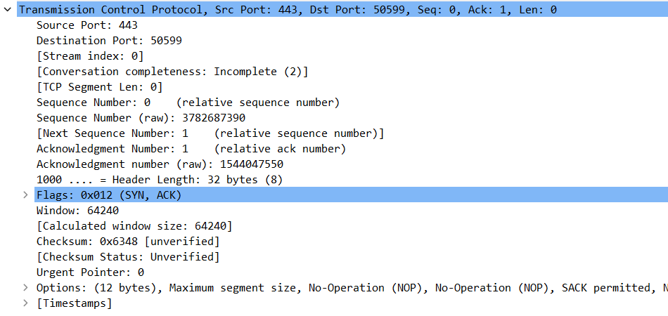
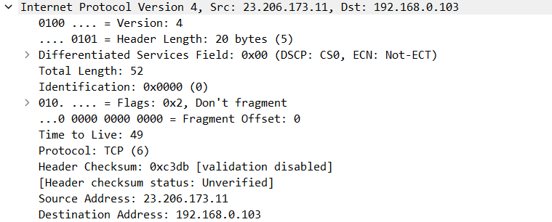

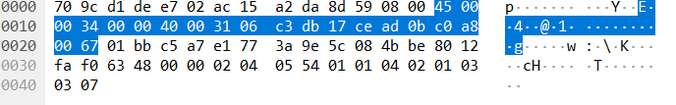

Observation & Learning
- Packet Capture: Wireshark effectively captured network traffic on the specified interface, allowing us to monitor the data packets as they passed through the network.
- Protocol Diversity: Wireshark identified and displayed a wide variety of network protocols, including common ones like TCP, IP, UDP, HTTP, and HTTPS. This diversity is essential for understanding the different types of traffic on the network.
- Packet Analysis: The tool enabled us to inspect individual packets, revealing detailed information about each one. This included source and destination IP addresses, port numbers, protocol-specific details, and the content of data payloads.
- Real-time Analysis: Wireshark's live capture feature provided real-time data, allowing us to monitor network activity as it happened. This proved valuable for troubleshooting and identifying issues promptly.
- Display Filters: The use of display filters made it easy to isolate and focus on specific aspects of network traffic, helping us pinpoint relevant information amid a large volume of data.
Conclusion
The use of Wireshark for analysing network traffic has proven to be an indispensable practice for maintaining a well-functioning and secure network. This tool not only provides a comprehensive view of network activity but also empowers us to diagnose issues, optimize network performance, and enhance our network's overall reliability and security. The insights gained from this analysis will be invaluable in our ongoing efforts to manage and improve our network infrastructure.

